Reg No: 221039016

1. Write and implement an C program for ARM microcontroller for the following: using timer 0, generate a delay of 50 milliseconds, to on and off the 4 led connected to P0.0 – P0.3, in a sequential way.

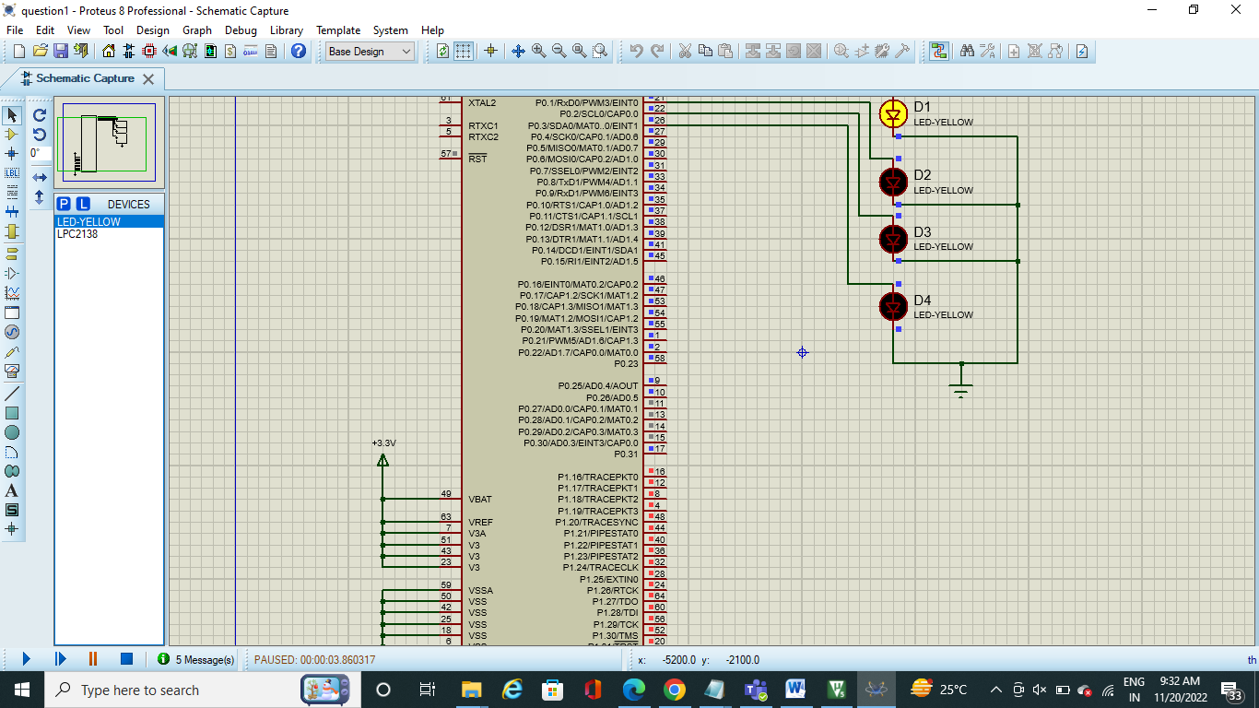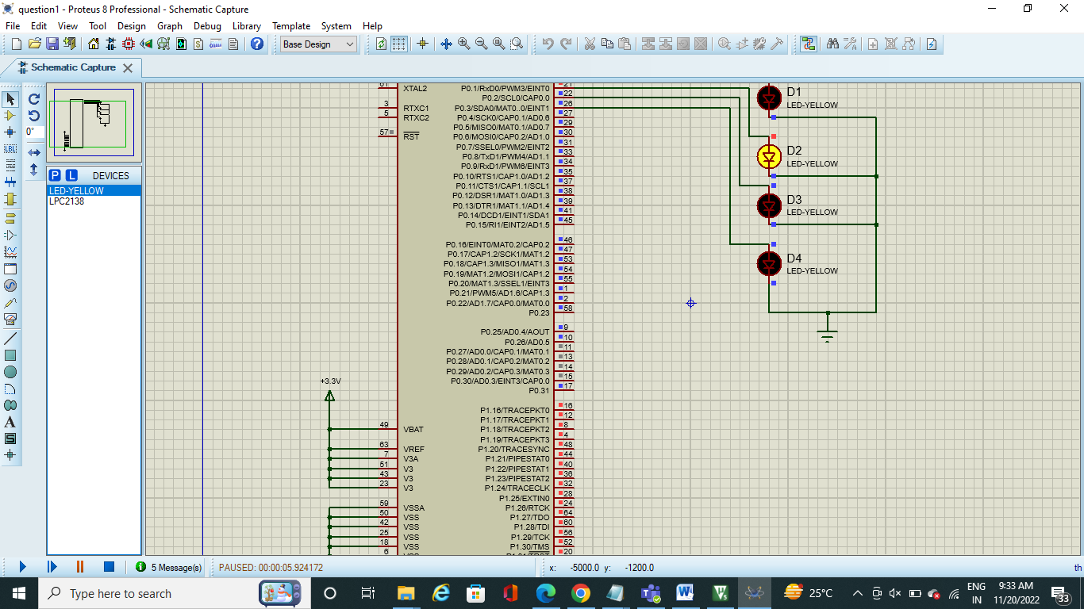

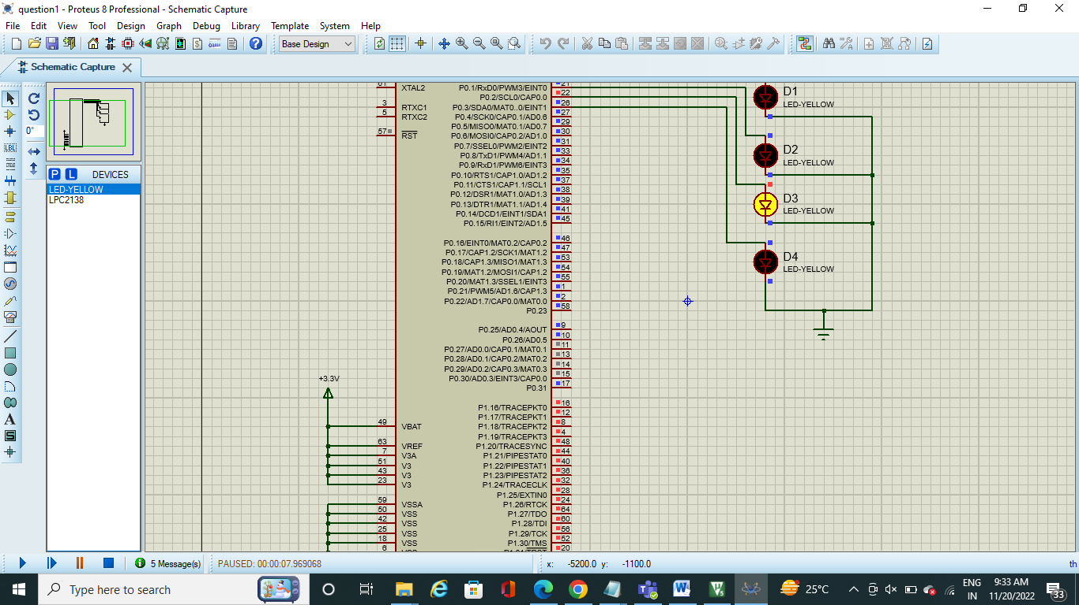

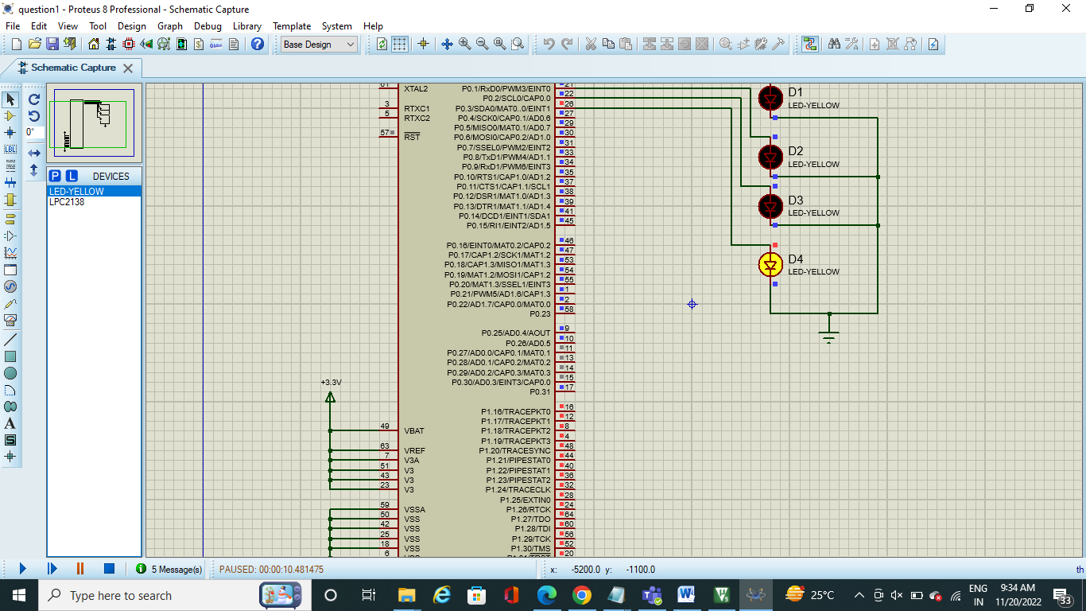

1. Write and implement an C program for ARM microcontroller for the following to receive a String(not char) and display on the LCD.

